**Technical Documentation – Stage_Compile_Deploy_ONLINE_Forms_Reports_PMP**

1. Workflow – Stages (from SVN), Compiles and Deploys Online Forms and Reports to an Environment.



1. Workflow Extra Vars

The Password Manager Pro URL is defined at the workflow level.

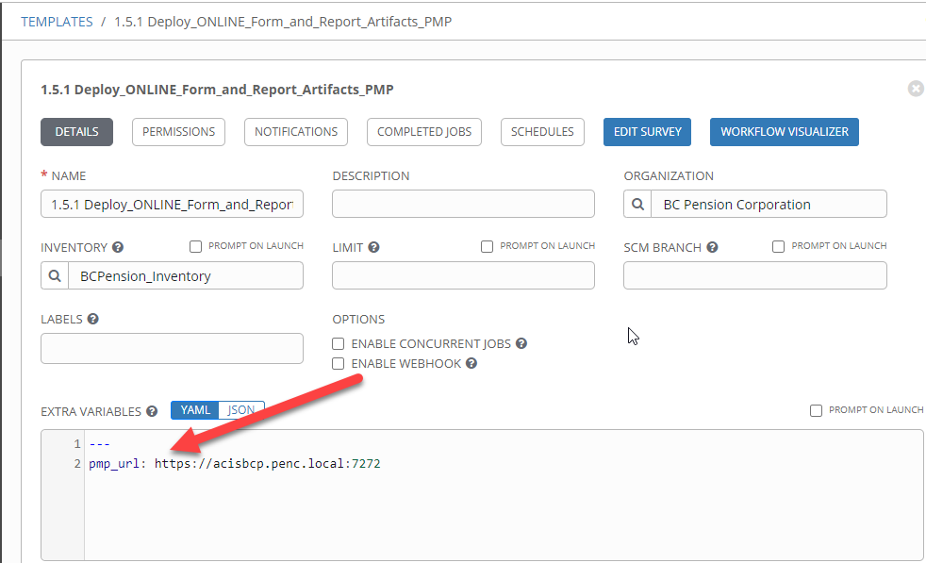

1. Survey – User Supplied Variables

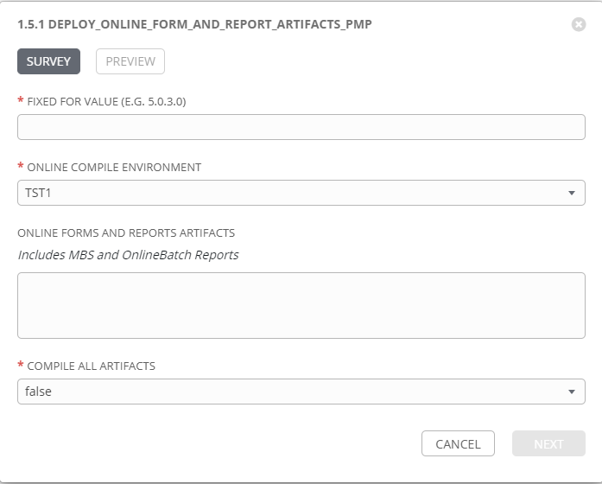

|  |  |  |  |
| --- | --- | --- | --- |
| **Survey Extra Variables** | **Prompt** | **Type** | **Description and Usage** |
| FFV | Fixed For Value | Text | The fixed for value for the deployment – must be for the format ###.###.###.### (i.e. 58.0.12.0). Numbers only with a maximum of 3 digits and there must be 4 sets separated with a ‘.’. Used to create staging and deployments directories. Used by all job templates in the workflow |
| ENV | Online Compile Enfironment | Multiple Choice Single Pick | The Environment to Compile and Deploy the FAR Artifact into: DEVL, DEV3, RDEV, TST1, TST2, TST3, MUAT, IPASP, TRNM. Only a single environment can be compiled in and deployed to per workflow execution |
| OnlineArtifacts | Online Forms and Reports Artifacts  Includes MBS and OnlineBatch Reports | Text Area 20,000 characters | The SVN URL for each FAR Artifact to be compiled and deployed. Each URL has to be on a separated line.  Note this variable is optional and if left blank the FAR Artifact(s) would have to have been staged by a previous execution. If the stage directory does not contain any artifacts the workflow will fail. |
| CompileAll | Compile All Artifacts | Multiple Choice Single Pick | True or false – default of false will only compile forms and reports that exist in the stage directory. If REFERENC.fmb or a pll is part of the deployment, CompileAll **MUST** be set to true, logic being all FAR Artifacts must be recompiled if either is deployed (re: Geoff G.). |

1. Jobs Used by the workflow - http://owl.penc.local:18080/svn/deploy_automation/trunk/Ansible_PlayBooks/FAR

| **Job Template** | **Ansible Playbook** | **Credentials / host** | **Project** | **Description and Usage** |
| --- | --- | --- | --- | --- |
| create_online_compile_playbook_vars | create_online_compile_playbook_vars.yml | None – runs on localhost as awx linux user | FAR Deployments | Batch_Compile_Directory: 'D:\Reports\defs\tst1'  Compile_Directory: /export_home/codemove/compile/ipas12c/tst1  DeploymentLogDir: /codemove_common/dp_automation/deployments/069.000/069.000.005.000/FAR  Oracle_DB: TST1  Runtime_Directory: /opt/ipas_app_test/tst1  StageDir: /codemove_common/dp_automation/stage/069.000/069.000.005.000/FAR  WEB_Compile_Directory: /export_home/codemove/compile/ipas12c/webt  batch_far_server: cronreptest1  far_server: daulis1bcp  rwconverter: 'D:\opt\oracle\domains\WLS_JCSTEST\reports\bin\rwconverter.bat'  stage_server: diagoras1bcp  tower_hostname: pdeploy1bcp.penc.local |
| stage_online_artifacts | stage_online_artifacts.yml | Codemove for {{stage_server}} – diagoras1bcp  pendeploy_svn – used to extract artifacts using the svn urls supplied. | FAR Deployments | When the OnlineArtifacts is populated with SVN URLs export the artifacts from SVN and place them in the Online Staging directory {{StageDir}}/artifacts/Online.  Creates a Staging file report in the {{DeploymentLogDir}} |
| check_online_staged_files | check_online_staged_files.yml | Codemove for {{stage_server}} – diagoras1bcp | FAR Deployments | Checks the {{StageDir}}/artifacts/Online to make sure at least one of *.fmb, *.rdf, *.pll, *.mmb, *.tif or *.olb file(s) exists. If there are no artifacts in the directory or the directory does not exist produce an error. |
| copy_far_artifacts_to_online | copy_far_artifacts_to_online.yml | Codemove for {{far_server}} typically daulis1bcp | FAR Deployments | Copies all FAR Artifacts staged into the {{Compile_Directory}}. If any *.olb or *.tif files exist copy them to the {{Runtime_Directory}} since they do NOT get processed by any of the compile playbooks. |
| compile_online_reports_pmp | compile_online_reports_pmp.yml  Calls  compile_single_report_pll.yml  and  compile_single_report.yml | Codemove for {{far_server}} typically daulis1bcp  PMP_ANSIBLE_AUTH_TOKEN for the Ansible Password Manager Pro API | FAR Deployments | compile_online_reports, compiles pll and rdf files.  Obtains the {{Schema}} Resource and Accound IDs from password managerpro using the {{ans_auth_token}} by passing in {{Schema}} and {{Oracle_DB}}_{{Schema}} to the getResourceAccountDetails API.  Obtains the password from Password Manager Pro by passing the RESOURCEID and ACCOUNTID to the getResourceAccountDetails API.  Checks the password against the {{Oracle_DB}} using sqlplus.  When CompileAll is true the compile_single_report_pll.yml is executed which will compile NOTC.pll, RPT_ROLE.pll and IPASRPT.pll. It is assumed CompileAll will be set to true if ANY new pll is deployed. By default it is set to ‘false’.  If any of the pll compiles produces an error {{Report_PLL_Errors}} is populated.  Each plx created is copied to {{Runtime_Directory}}.  {{Report_PLL_Feedback}} is populated for each plx created.  When CompileAll is true compile_single_report.yml is executed against ALL rdf files in the {{Compile_Directory}}. If CompileAll is false, compile_single_report.yml is executed only against rdf files in the {{StageDir}}/artifacts/Online.  If any of the rdf compiles produces an error {{Report_Errors}} is populated.  Each rep created is copied to {{Runtime_Directory}}.  {{Report_Feedback}} is populated for each rep created. |
| compile_forms | compile_forms.yml  Calls  compile_single_form_pll.yml  and  compile_single_menu.yml  and  compile_single_form.yml | Codemove for {{far_server}} typically daulis1bcp | FAR Deployments | Compile_forms compiles oracle forms plls, forms menus and forms.  Obtains the {{Schema}} Resource and Accound IDs from password managerpro using the {{ans_auth_token}} by passing in {{Schema}} and {{Oracle_DB}}_{{Schema}} to the getResourceAccountDetails API.  Obtains the password from Password Manager Pro by passing the RESOURCEID and ACCOUNTID to the getResourceAccountDetails API.  Checks the password against the {{Oracle_DB}} using sqlplus.  When CompileAll is set to true compile_single_form_pll.yml is called to compile all plls. When a new form pll is migrated it is assumed that CompileAll is set to true, by default it is set to false and NO plls are compiled.  If any of the pll compiles result in an error {{Form_PLL_Errors}} is updated.  {{Form_PLL_Feedback}} is updated for each plx created.  When CompileAll is set to true compile_single_menu.yml is executed against all mmb files in the {{Compile_Directory}}. If CompileAll is set to false compile_single_menu.yml is executed against all mmb files in the {{StageDir}}/artifacts/Online directory. The resulting mmx files are copied to the {{Runtime_Directory}}.  If any of the mmb compiles result in an error {{Form_Menus_Errors}} is updated.  {{Form_Menu_Feedback}} is updated for each mmx created.  When CompileAll is set to true compile_forms.yml compiles the REFERENC.fmb.  If REFERENC.fmb fails to compile {{Referenc_Forms_Errors}} is updated.  If REFERENC.fmb compiles successfully, the resulting fmx is removed and the compiled REFERENC.fmb is copied to the {{Runtime_Directory}}. REFERENCE.fmb is ONLY compiled when CompileAll is set to true as ALL Forms will need to be compiled if a new REFERENC.fmb is deployed.  When CompileAll is set to true compile_single_form.yml is executed against all fmb files in the {{Compile_Directory}}. If CompileAll is set to false compile_single_form.yml is executed against all fmb files in the {{StageDir}}/artifacts/Online directory. The resulting fmx files are copied to the {{Runtime_Directory}}.  If any of the fmb compiles result in an error {{Form_Errors}} is updated.  {{Form_Feedback}} is updated for each fmx created. |
| consolidate_compile_errors | consolidate_compile_errors.yml | None – runs on localhost as awx linux user | FAR Deployments | Consolidates all ERRORS generated – Note that this jobs is used by all Forms and Reports workflows (Online, Batch, web, etc.). |
| populate_online_deployment_logs | populated_online_deployment_logs.yml | Codemove for {{stage_server}} – diagoras1bcp | FAR Deployments | Populates the deployment log {{DeploymentLogDir}}/{{ENV}}_Online_Log.html with the pll, mmb, fmb and rdf feedback generated during the compiles.  Populates the error log {{DeploymentLogDir}}/{{ENV}}_Online_Compile_Errors.html with any ERRORS generated during the compiles.  If Compile errors exist emails the {{DeploymentLogDir}}/{{ENV}}_Online_Compile_Errors.html file to:  - PENC_ITS_ADM_Release_Management@Victoria1.gov.bc.ca  - PENC_ITS_TSS_Midtier@Victoria1.gov.bc.ca |